Lab 3: Uninformed Search: BFS, DFS, DLS, IDDFS

Course:
Artificial Intelligence Lab

Submitted by:
Aman Khawar

Roll Number:
SU-92-BSSEM-S25-019

Section:
BSSE-4A

Submitted to:
Rasikh Ali

Task 1:
Trace BFS and DFS manually:
1. Objective:
The objective of this task is to manually trace breadth-first search (BFS) and depth-first search (DFS). The starting node is A and the goal node is G. The queue or stack nodes, processed nodes, visited order and final path of the recoding for both algorithms.
2. Graph:
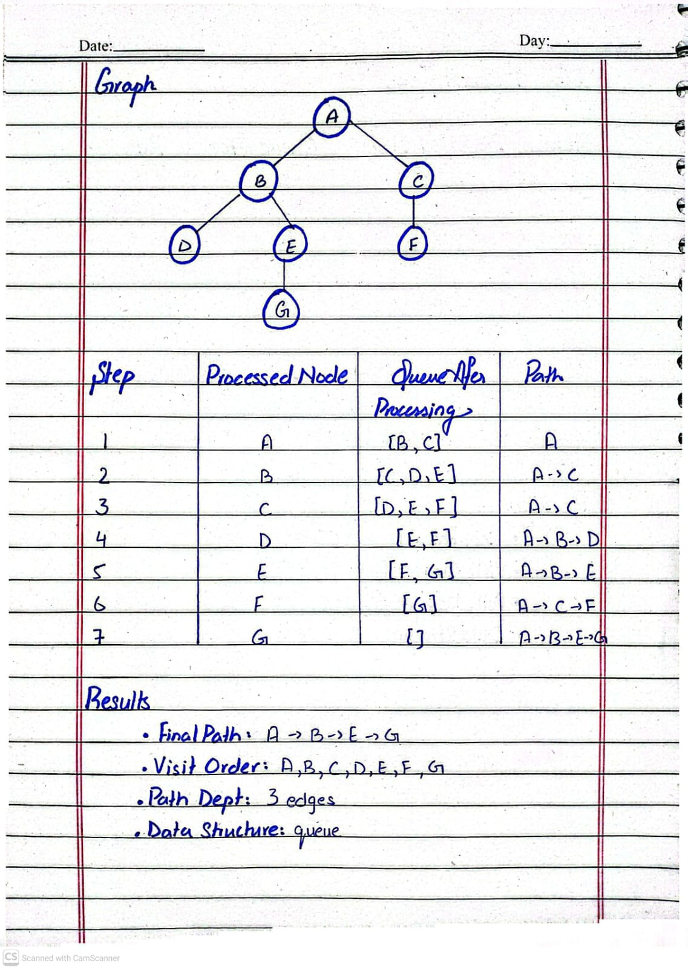
3. Breath-First Search:
BFS explores the graph level by level.it uses a queue that follows the First In, first out (FIFO) principal. The first node added to the to the queue is the first node processed.

4.BFS manually Trace:
Step | Processed Node | Queue after processing | Path
1 | A | [B, C] | A
2 | B | [C, D, E] | A -> C
3 | C | [D, E, F] | A -> C
4 | D | [E, F] | A -> B -> D
5 | E | [F, G] | A -> B -> E
6 | F | [G] | A -> C -> F
7 | G | [] | A -> B -> E -> G

BFS Results:
- Final Path: A -> B -> E -> G
- Visit Order: A, B, C, D, E, F, G
- Path Depth: 3 edges
- Data Structure: Queue

5. Depth-First Search (DFS):
DFS explores one branch as deeply as possible before returning to another branch. It uses a stack that follows the Last In, First Out (LIFO) principle. To visit the first listed successor first, the successors are pushed onto the stack in reverse order.

DFS manually Trace:
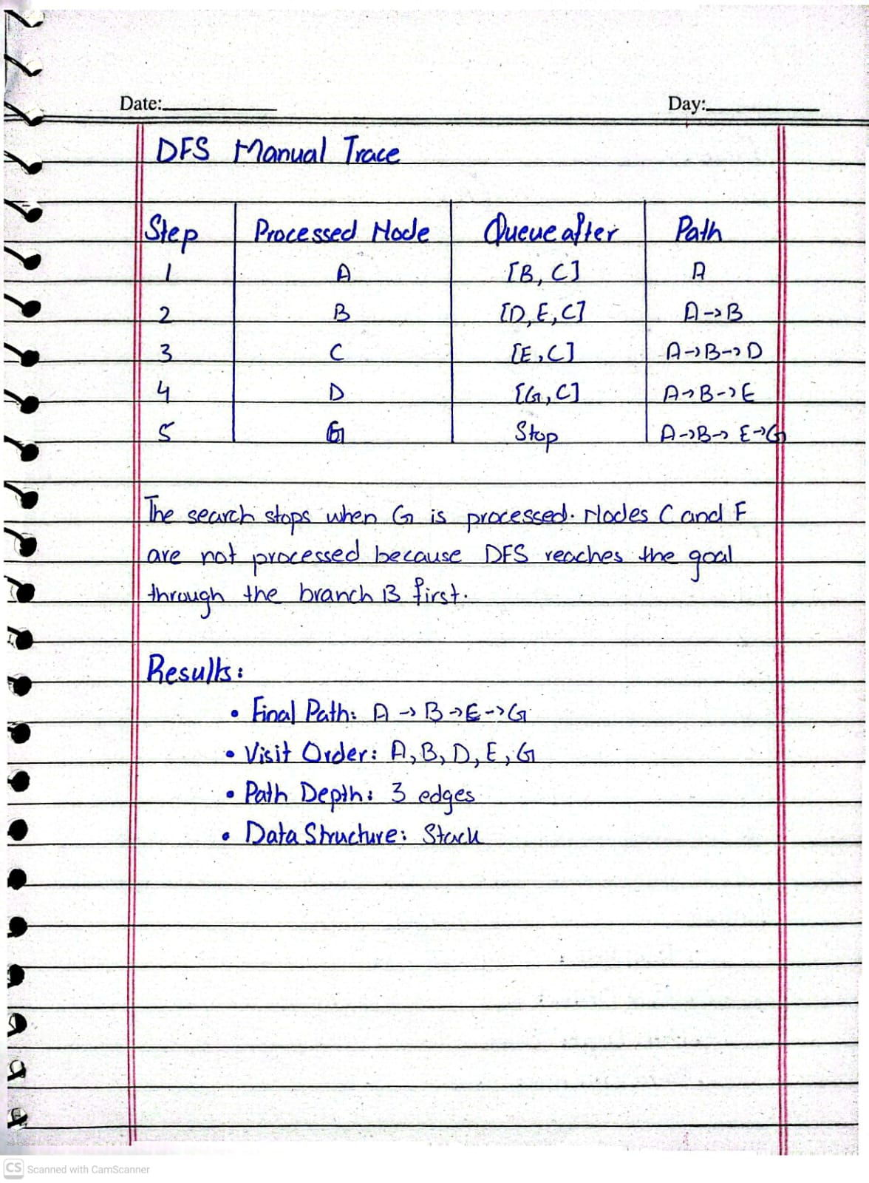

6. DFS:
Step | Processed Node | Queue after processing | Path
1 | A | [B, C] | A
2 | B | [D, E, C] | A -> B
3 | C | [E, C] | A -> B -> D
4 | D | [G, C] | A -> B -> E
5 | G | Stop | A -> B -> E -> G

The search stops when G is processed. Nodes C and F are not processed because DFS reaches the goal through the B branch first.
DFS Results:
- Final Path: A -> B -> E -> G
- Visit Order: A, B, D, E, G
- Path Depth: 3 edges
- Data Structure: Stack
7. Verification:
The manual traces are verified against the supplied BFS and DFS code. Both algorithms return the path A ->B ->E -> G. However, their visit orders are different because they explore the graph using different strategies.
BFS processes the nodes in queue order, while DFS follows the first branch deeply using a stack. The goal node G is included in the visit order, and processing stops when the goal is reached.
For verification I’ve run the code 3.2 BFS and DFS provided in the lab manual in my lab3_bfs_dfs.py file and it returns the following output:
['A', 'B', 'E', 'G']
['A', 'B', 'E', 'G']
This output match with the final paths obtained through manual tracing.
8. Conclusion:
BFS and DFS found the same path from A to G but followed different visit orders. BFS explores level by level, while DFS explores one branch deeply.

Task 2:
Implement DLS and IDDFS:
1. Objective:
In this task, I implemented and tested Depth-Limited Search (DLS) and Iterative Deepening DFS (IDDFS) on the graph. I tested both algorithms with different depth limits from 1 to 4. The starting node is A, and the goal node is G. The depth of the starting node is counted as 0.
2. Depth-Limited Search (DLS):
DLS works like DFS, but it does not explore beyond the given depth limit. It checks whether the goal can be reached within that limit. It can return three different statuses:
- FOUND: The goal node G has been reached.
- CUTOFF: The search reaches its depth limit, but the goal has not been found.
- FAILURE: The search cannot find the goal, and no further path is available to explore.
3. DLS Results:
Depth Limit | Status
  Path
  Explanation
1 | CUTOFF | None | G cannot be reached within one edge.
2 | CUTOFF | None | G cannot be reached within two edges.
3 | FOUND | A -> B -> E -> G | G is reached at depth 3
4 | FOUND | A -> B -> E -> G | G is found before the depth limit is exceeded.

4. Iterative Deepening DFS (IDDFS):
IDDFS combines the idea of DFS with increasing depth limits. It starts with depth 0 and increases the limit until the goal is found. Each new search starts from A again. A path-local cycle check is used to avoid revisiting a node already present on the current path.

5. IDDFS Results:
Maximum Depth | Limits Attempted | Status | Path
1 | 0, 1 | CUTOFF | None
2 | 0,1,2 | CUTOFF | None
3 | 0,1,2,3 | FOUND | A -> B -> E -> G
4 | 0,1,2,3, | FOUND | A -> B -> E -> G

7. Explanation:
In this task, I tested DLS and IDDFS with different depth limits. Both algorithms found the path A -> B -> E -> G when the search reached depth 3. I learned that DLS uses a fixed limit, while IDDFS increases the limit step by step.

